SE2030 – Software Engineering
Design Document
StockFlow – Web-based Inventory Control System
2026-Y2-S1-MLB-B6G2-10
IT25101700 | Priyabhashitha G.J.S.
IT25102511 | Wickramathunga M.W.C.L.
IT25103597 | Kularathne R.T.M.
IT25101519 | Kavindi W.L.P.R.
IT25103401 | Fernando T.M.B.
IT25100596 | Ranesh H.D.D.


Agile Sprint Summary
Sprints Overview
We planned the project as four sprints of three weeks each (Weeks 3 to 14). Every member owns one major function from the UI down to the database, and Priyabhashitha G.J.S. (group leader) also handles merging and keeping the UI consistent. Work is tracked with GitHub issues and feature branches that are merged through pull requests.
- 1st Sprint (Weeks 3 – 5) - Complete
  - Login, user accounts and role setup
  - Product catalogue, suppliers, warehouses, storage locations and product search
- 2nd Sprint (Weeks 6 – 8) - Complete
  - Purchase orders with order items and approval status
  - Goods receipts with accepted and rejected quantities
  - Batch and expiry records, inventory balance and stock movements
- 3rd Sprint (Weeks 9 – 11) - Complete
  - Stock transfers, stock issues and stock returns
  - Stock availability checks before stock leaves a location
  - Stock counts, variance calculation and the stock adjustment approval flow
- 4th Sprint (Weeks 12 – 14) - In Progress
  - Reorder rules and notifications (done)
  - Dashboard, reports and audit trail (being finished)
  - End-to-end testing, bug fixing, final documentation and demo
1st Sprint
The first sprint was mostly about getting a base that everyone could build on. We agreed on the package structure, created the shared MySQL schema and set up Spring Boot with Thymeleaf. Login with BCrypt passwords and the five user roles were added early because every other page depends on who is logged in. Product, supplier and warehouse pages and a simple product search were finished by the end of the sprint.
2nd Sprint
This sprint focused on the purchasing side. Purchase orders can now be created with several items and go through draft and approval. Goods receipts are recorded against approved orders with delivered, accepted and rejected quantities, and batch and expiry details are saved for batch-tracked products. We also built the inventory balance and stock movement classes here, since receiving is the first place stock actually changes. Some validation took longer than planned and was moved to Sprint 3.
3rd Sprint
In Sprint 3 we completed the stock operations. Transfers move stock between two locations (draft, approve, dispatch, receive), and issues and returns update the balance only after they are confirmed. The system checks available stock before any stock leaves a location. Stock counts compare the recorded and counted quantities, and adjustments need Operations Manager approval before the balance is changed.
4th Sprint
The last sprint is still in progress. Reorder rules and notifications are working. We still need to finish the dashboard figures and report filters, complete the audit trail, run end-to-end tests with each role, fix integration bugs and prepare the final demo and submission.
Sprint Plan
Definition of Done: a story is done when the function works, validation is in place, basic tests pass, the code is merged to the shared repository and the group can demo the workflow.
1st Sprint (Weeks 3 – 5)
Priyabhashitha G.J.S. (IT25101700) - T-01 / 10 hours
Wickramathunga M.W.C.L. (IT25102511) - T-02 / 10 hours
Fernando T.M.B. (IT25103401) - T-03 / 8 hours
Kularathne R.T.M. (IT25103597) - T-04 / 8 hours
Kavindi W.L.P.R. (IT25101519) - T-05 / 6 hours
Ranesh H.D.D. (IT25100596) - T-06 / 8 hours

Sprint ID | User Story | Priority | Status
SP1-01 | As an IT officer, I want to create user accounts and give each one a role so that staff only see the functions they need. | High | Complete
SP1-02 | As a store supervisor, I want to add products with a category, brand and unit so that all modules use one product list. | High | Complete
SP1-03 | As a finance executive, I want to keep supplier details in the system so that I can place purchase orders with them. | High | Complete
SP1-04 | As a store supervisor, I want to set up warehouses and storage locations so that stock can be tracked by location. | High | Complete
SP1-05 | As a staff member, I want to search products by SKU, barcode or name so that I can find an item quickly. | Medium | Complete
Tasks
Task ID | Task | Est. Hours
User accounts and role access (T-01)
T-01.1 | Create user account table, entity and repository | 2
T-01.2 | Set up Spring Security login with BCrypt passwords | 3
T-01.3 | Add access rules for the five roles | 2
T-01.4 | User account pages for the IT officer and testing | 3
Product catalogue (T-02)
T-02.1 | Create product, category, brand and unit tables | 2
T-02.2 | Product service and controller (add, edit, deactivate) | 4
T-02.3 | Product form and list pages, unique SKU/barcode check | 2
T-02.4 | Testing and debugging | 2
Suppliers (T-03)
T-03.1 | Supplier table and CRUD service | 3
T-03.2 | Supplier pages with email and phone validation | 3
T-03.3 | Testing with sample data | 2
Warehouses and storage locations (T-04)
T-04.1 | Warehouse and storage location tables | 2
T-04.2 | Warehouse CRUD and locations under each warehouse | 4
T-04.3 | Testing and debugging | 2
Product search (T-05)
T-05.1 | Search query by SKU, barcode and name | 3
T-05.2 | Search box and result list, testing | 3
General tasks (T-06)
T-06.1 | Project setup, shared schema and GitHub branches | 4
T-06.2 | Merge and integration testing | 4
2nd Sprint (Weeks 6 – 8)
Fernando T.M.B. (IT25103401) - T-07, T-08 / 12 hours
Ranesh H.D.D. (IT25100596) - T-09, T-10 / 14 hours
Priyabhashitha G.J.S. (IT25101700) - T-11 / 8 hours
Wickramathunga M.W.C.L. (IT25102511) - T-12 / 6 hours
Kularathne R.T.M. (IT25103597) - T-13 / 4 hours
Kavindi W.L.P.R. (IT25101519) - T-13 / 4 hours

Sprint ID | User Story | Priority | Status
SP2-01 | As a finance executive, I want to create a purchase order with several items and prices so that I can order stock from a supplier. | High | Complete
SP2-02 | As an operations manager, I want to approve purchase orders before they are sent so that spending is controlled. | High | Complete
SP2-03 | As a store supervisor, I want to record delivered, accepted and rejected quantities so that only good stock enters inventory. | High | Complete
SP2-04 | As a store supervisor, I want to save batch numbers and expiry dates so that expiring stock can be found. | High | Complete
SP2-05 | As a store supervisor, I want every stock change saved as a movement so that stock history can be checked later. | Medium | Complete
Tasks
Task ID | Task | Est. Hours
Purchase orders (T-07)
T-07.1 | Purchase order and order item tables | 2
T-07.2 | Create and edit orders, line and order totals | 4
T-07.3 | Order pages and testing | 2
Purchase order approval (T-08)
T-08.1 | Draft / approved / cancelled status handling | 2
T-08.2 | Approve action restricted to the Operations Manager | 2
Goods receiving (T-09)
T-09.1 | Goods receipt and receipt item tables | 2
T-09.2 | Record delivered, accepted and rejected quantities | 3
T-09.3 | Check quantities against the outstanding order amount | 2
T-09.4 | Receipt pages and testing | 2
Batches and expiry (T-10)
T-10.1 | Batch table and batch creation on receipt | 3
T-10.2 | Testing with batch-tracked products | 2
Inventory balance and movements (T-11)
T-11.1 | Inventory balance per product, location and batch | 3
T-11.2 | Stock movement record for every change | 3
T-11.3 | Unit tests for add and remove quantity | 2
Reference data (T-12)
T-12.1 | Maintain categories, brands and units (no hard delete) | 4
T-12.2 | Testing | 2
General tasks (T-13)
T-13.1 | Merge branches and integration testing | 6
T-13.2 | Clean up duplicated code | 2
3rd Sprint (Weeks 9 – 11)
Kularathne R.T.M. (IT25103597) - T-14 / 10 hours
Kavindi W.L.P.R. (IT25101519) - T-15, T-16 / 13 hours
Priyabhashitha G.J.S. (IT25101700) - T-17, T-18 / 14 hours
Wickramathunga M.W.C.L. (IT25102511) - T-19 / 6 hours
Fernando T.M.B. (IT25103401) - T-19 / 6 hours
Ranesh H.D.D. (IT25100596) - T-19 / 6 hours

Sprint ID | User Story | Priority | Status
SP3-01 | As a store supervisor, I want to move stock between locations so that each warehouse has what it needs. | High | Complete
SP3-02 | As a store supervisor, I want to issue stock to a customer or department so that the balance goes down straight away. | High | Complete
SP3-03 | As a store supervisor, I want to record returned items and whether they can be restocked so that returns are handled correctly. | Medium | Complete
SP3-04 | As an operations manager, I want the system to block issues and transfers when stock is not enough so that balances never go negative. | High | Complete
SP3-05 | As an inventory control officer, I want to enter counted quantities and see the variance so that I can find stock differences. | High | Complete
SP3-06 | As an operations manager, I want to approve or reject stock adjustments so that stock is not changed without a reason. | High | Complete
Tasks
Task ID | Task | Est. Hours
Stock transfers (T-14)
T-14.1 | Transfer and transfer item tables | 2
T-14.2 | Approve, dispatch and receive steps with stock movements | 5
T-14.3 | Transfer pages and testing | 3
Stock issues (T-15)
T-15.1 | Recipients, issue and issue item tables | 2
T-15.2 | Confirm issue and reduce the balance | 3
T-15.3 | Issue pages and testing | 2
Stock returns (T-16)
T-16.1 | Return against an issue with restock and rejected quantities | 4
T-16.2 | Testing and debugging | 2
Stock counts (T-17)
T-17.1 | Stock count and count item tables | 2
T-17.2 | Enter counted quantity and calculate variance | 3
T-17.3 | Testing | 2
Stock adjustments (T-18)
T-18.1 | Adjustment draft, submit, approve and reject | 4
T-18.2 | Apply approved adjustment to the balance | 2
T-18.3 | Testing | 1
General tasks (T-19)
T-19.1 | Availability checks shared by transfer and issue | 4
T-19.2 | Full integration testing across all modules | 8
T-19.3 | Unified sidebar, pagination and confirmation dialogs | 6
4th Sprint (Weeks 12 – 14)
Priyabhashitha G.J.S. (IT25101700) - T-20, T-21, T-22 / 16 hours
Wickramathunga M.W.C.L. (IT25102511) - T-23 / 8 hours
Fernando T.M.B. (IT25103401) - T-23 / 8 hours
Ranesh H.D.D. (IT25100596) - T-23 / 8 hours
Kularathne R.T.M. (IT25103597) - T-24 / 8 hours
Kavindi W.L.P.R. (IT25101519) - T-24 / 8 hours

Sprint ID | User Story | Priority | Status
SP4-01 | As an operations manager, I want to set minimum and reorder levels so that I know when a product needs to be ordered. | Medium | Complete
SP4-02 | As a user, I want to get notifications for low stock and pending approvals so that nothing is missed. | Medium | Complete
SP4-03 | As an operations manager, I want a dashboard and reports so that I can see the stock situation at a glance. | Medium | In Progress
SP4-04 | As an operations manager, I want important actions saved in an audit log so that I can check who changed what. | Medium | In Progress
SP4-05 | As a group, we want every workflow tested end to end with each role so that the final demo works without errors. | High | In Progress
Tasks
Task ID | Task | Est. Hours
Reorder rules and alerts (T-20)
T-20.1 | Reorder rule per product with minimum and maximum levels | 3
T-20.2 | Low stock and out-of-stock alerts | 2
Notifications (T-21)
T-21.1 | Notification list, unread count and mark as read | 3
Dashboard, reports and audit trail (T-22)
T-22.1 | Dashboard summary figures | 2
T-22.2 | Stock, movement and purchase reports with CSV export | 3
T-22.3 | Audit log for approvals and important actions | 3
Testing and fixing (T-23)
T-23.1 | End-to-end tests with each role account | 12
T-23.2 | Fix integration bugs and check MySQL data | 8
T-23.3 | Performance and security checks | 4
Documentation and demo (T-24)
T-24.1 | Final report and short user guide | 8
T-24.2 | Demo data and viva preparation | 8

Use Case Diagram
The diagram below shows the actors of StockFlow and what each one can do. All actors inherit Log In and Reset Password from the System User. The Store Supervisor handles the daily stock work, the Finance Executive handles suppliers and purchase orders, the Inventory Control Officer does counts, adjustments and reorder rules, and the Operations Manager approves purchase orders and stock adjustments.
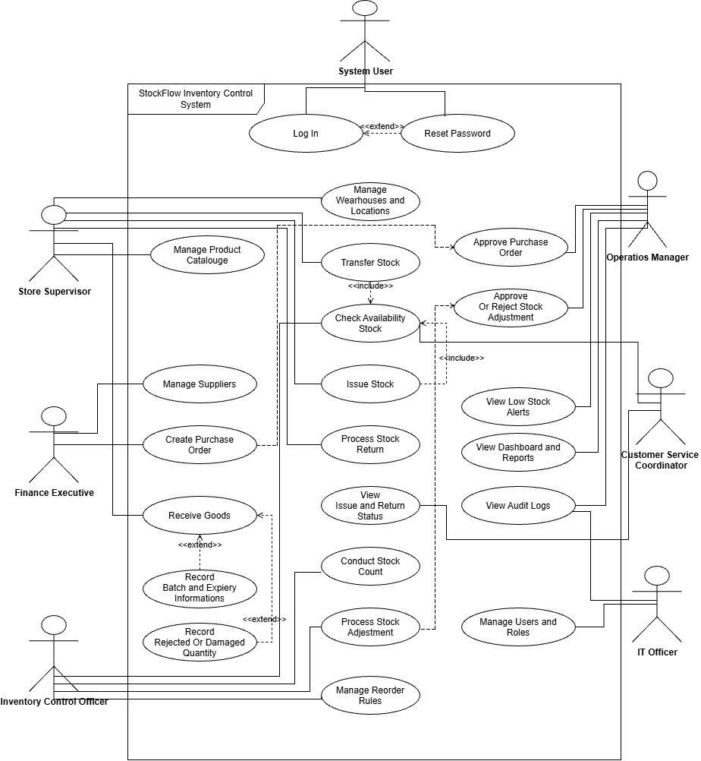

Class Diagram
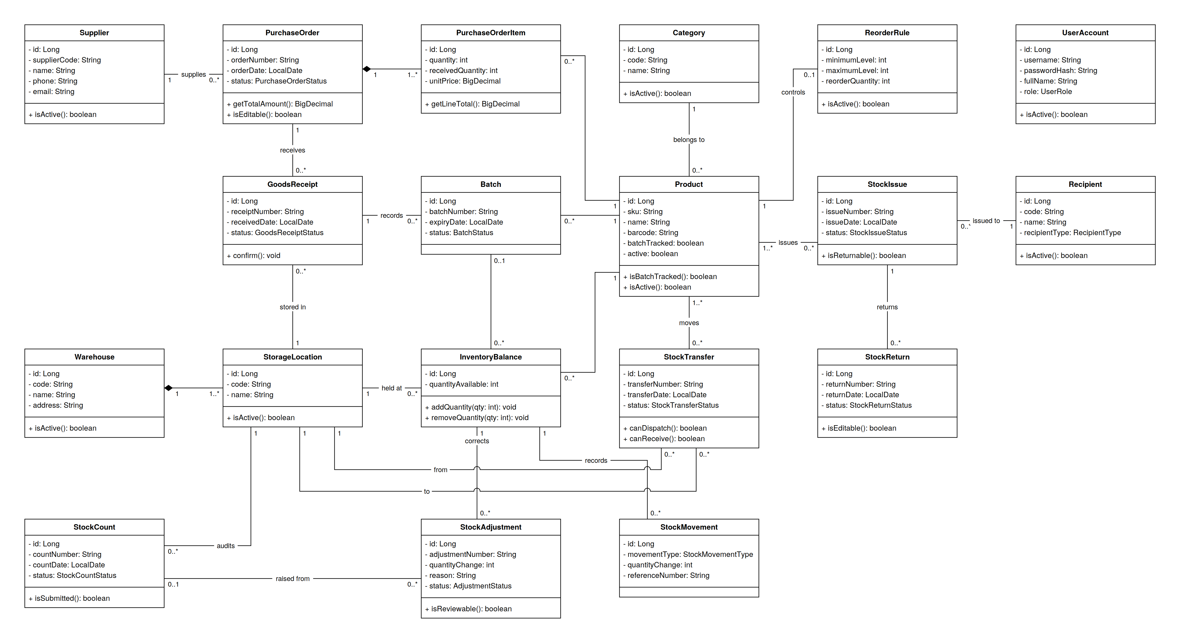
The diagram shows the main entity classes of StockFlow with their key attributes, methods and relationships.

Activity Diagrams
1. Manage Product Catalogue
Wickramathunga M.W.C.L. (IT25102511)
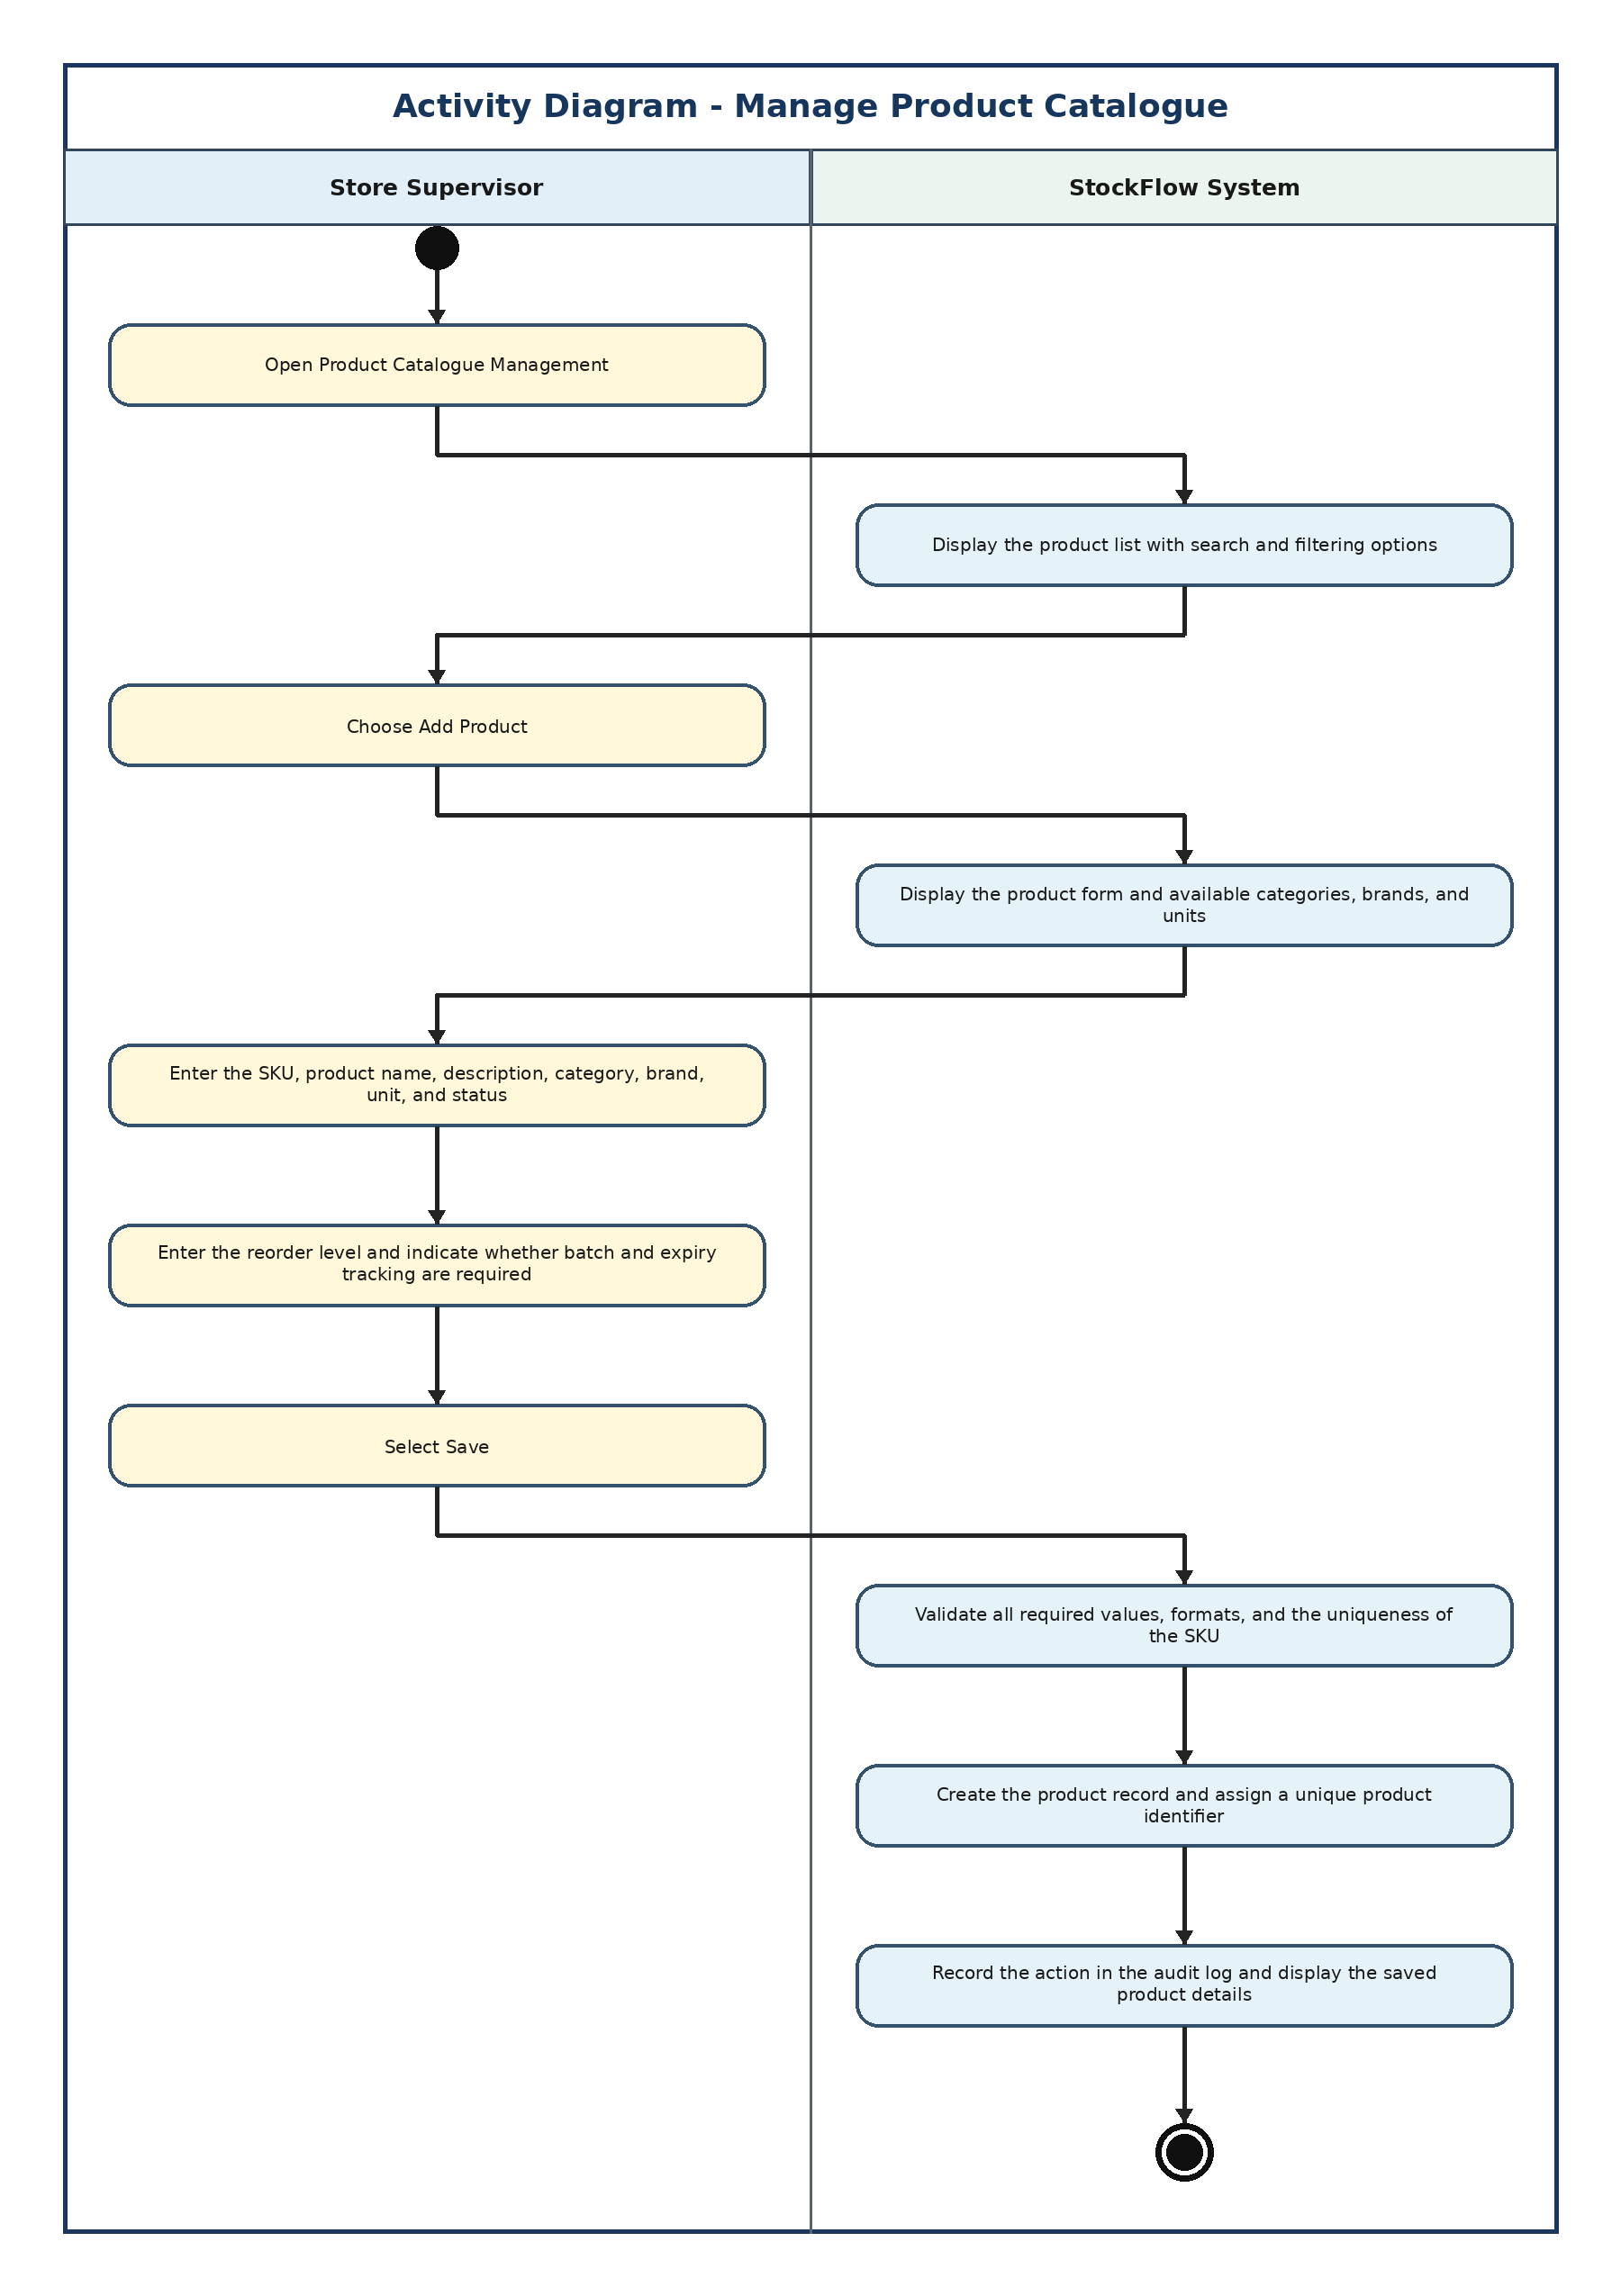

2. Create Purchase Order
Fernando T.M.B. (IT25103401)
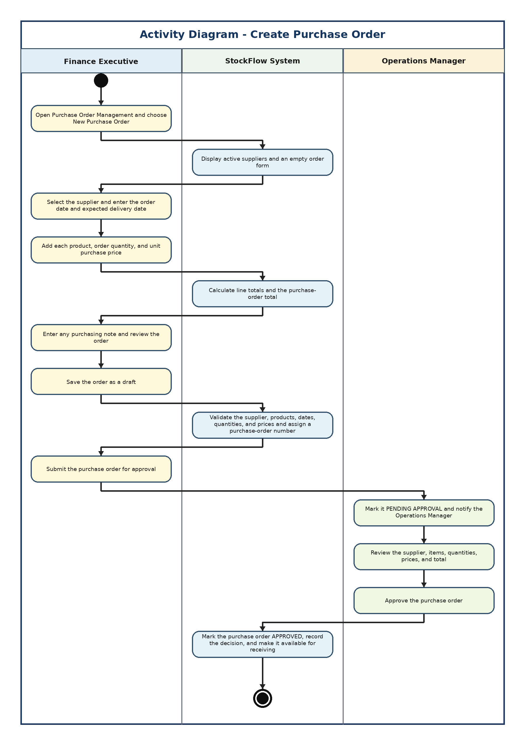

3. Receive Goods
Ranesh H.D.D. (IT25100596)
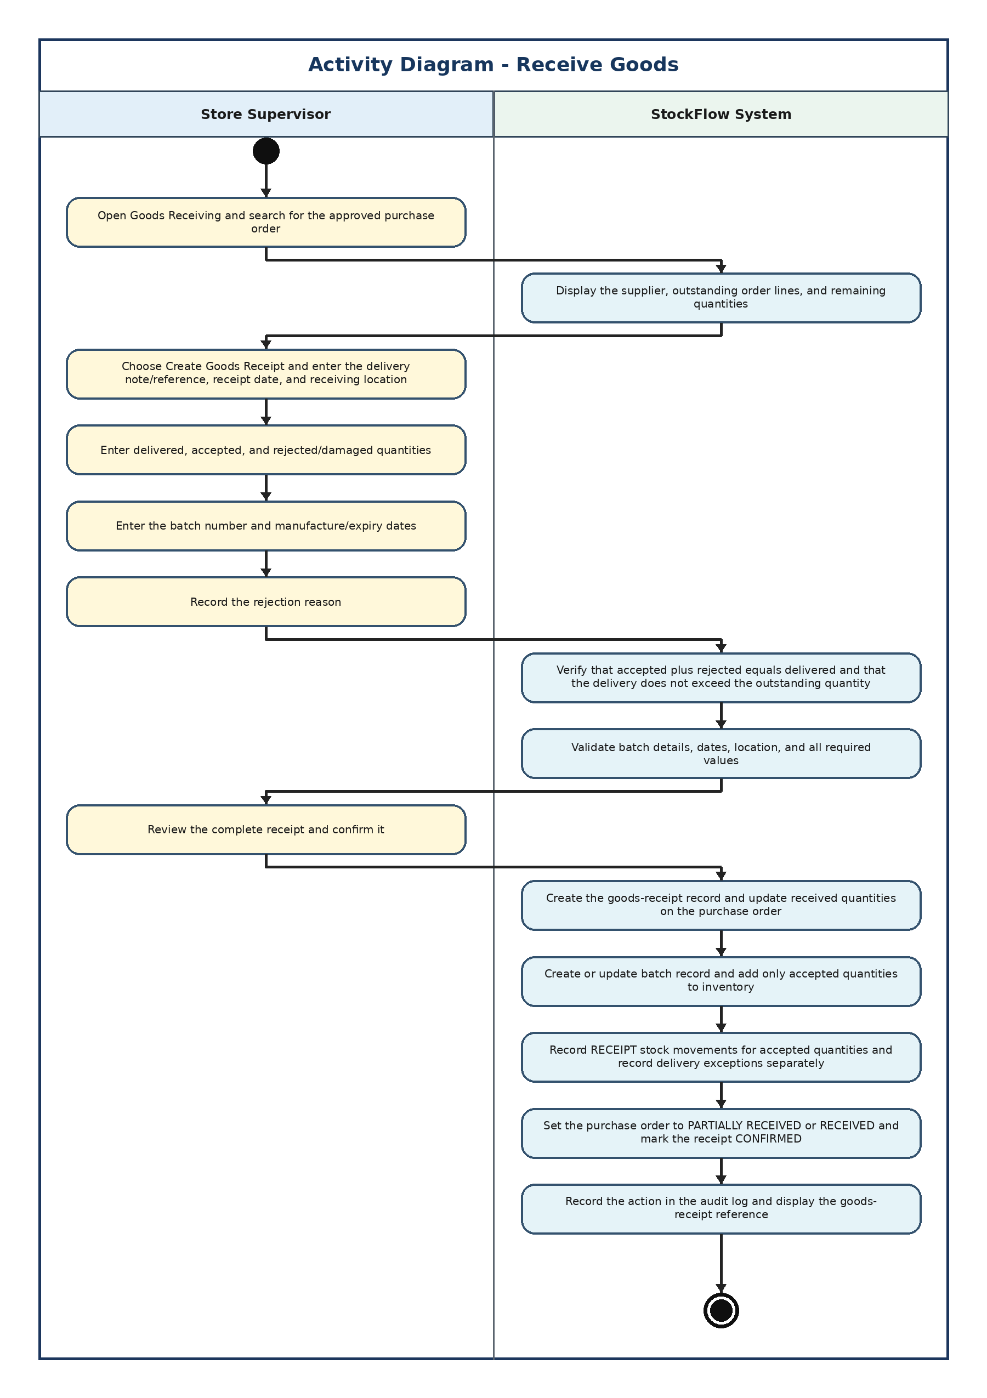

4. Transfer Stock
Kularathne R.T.M. (IT25103597)
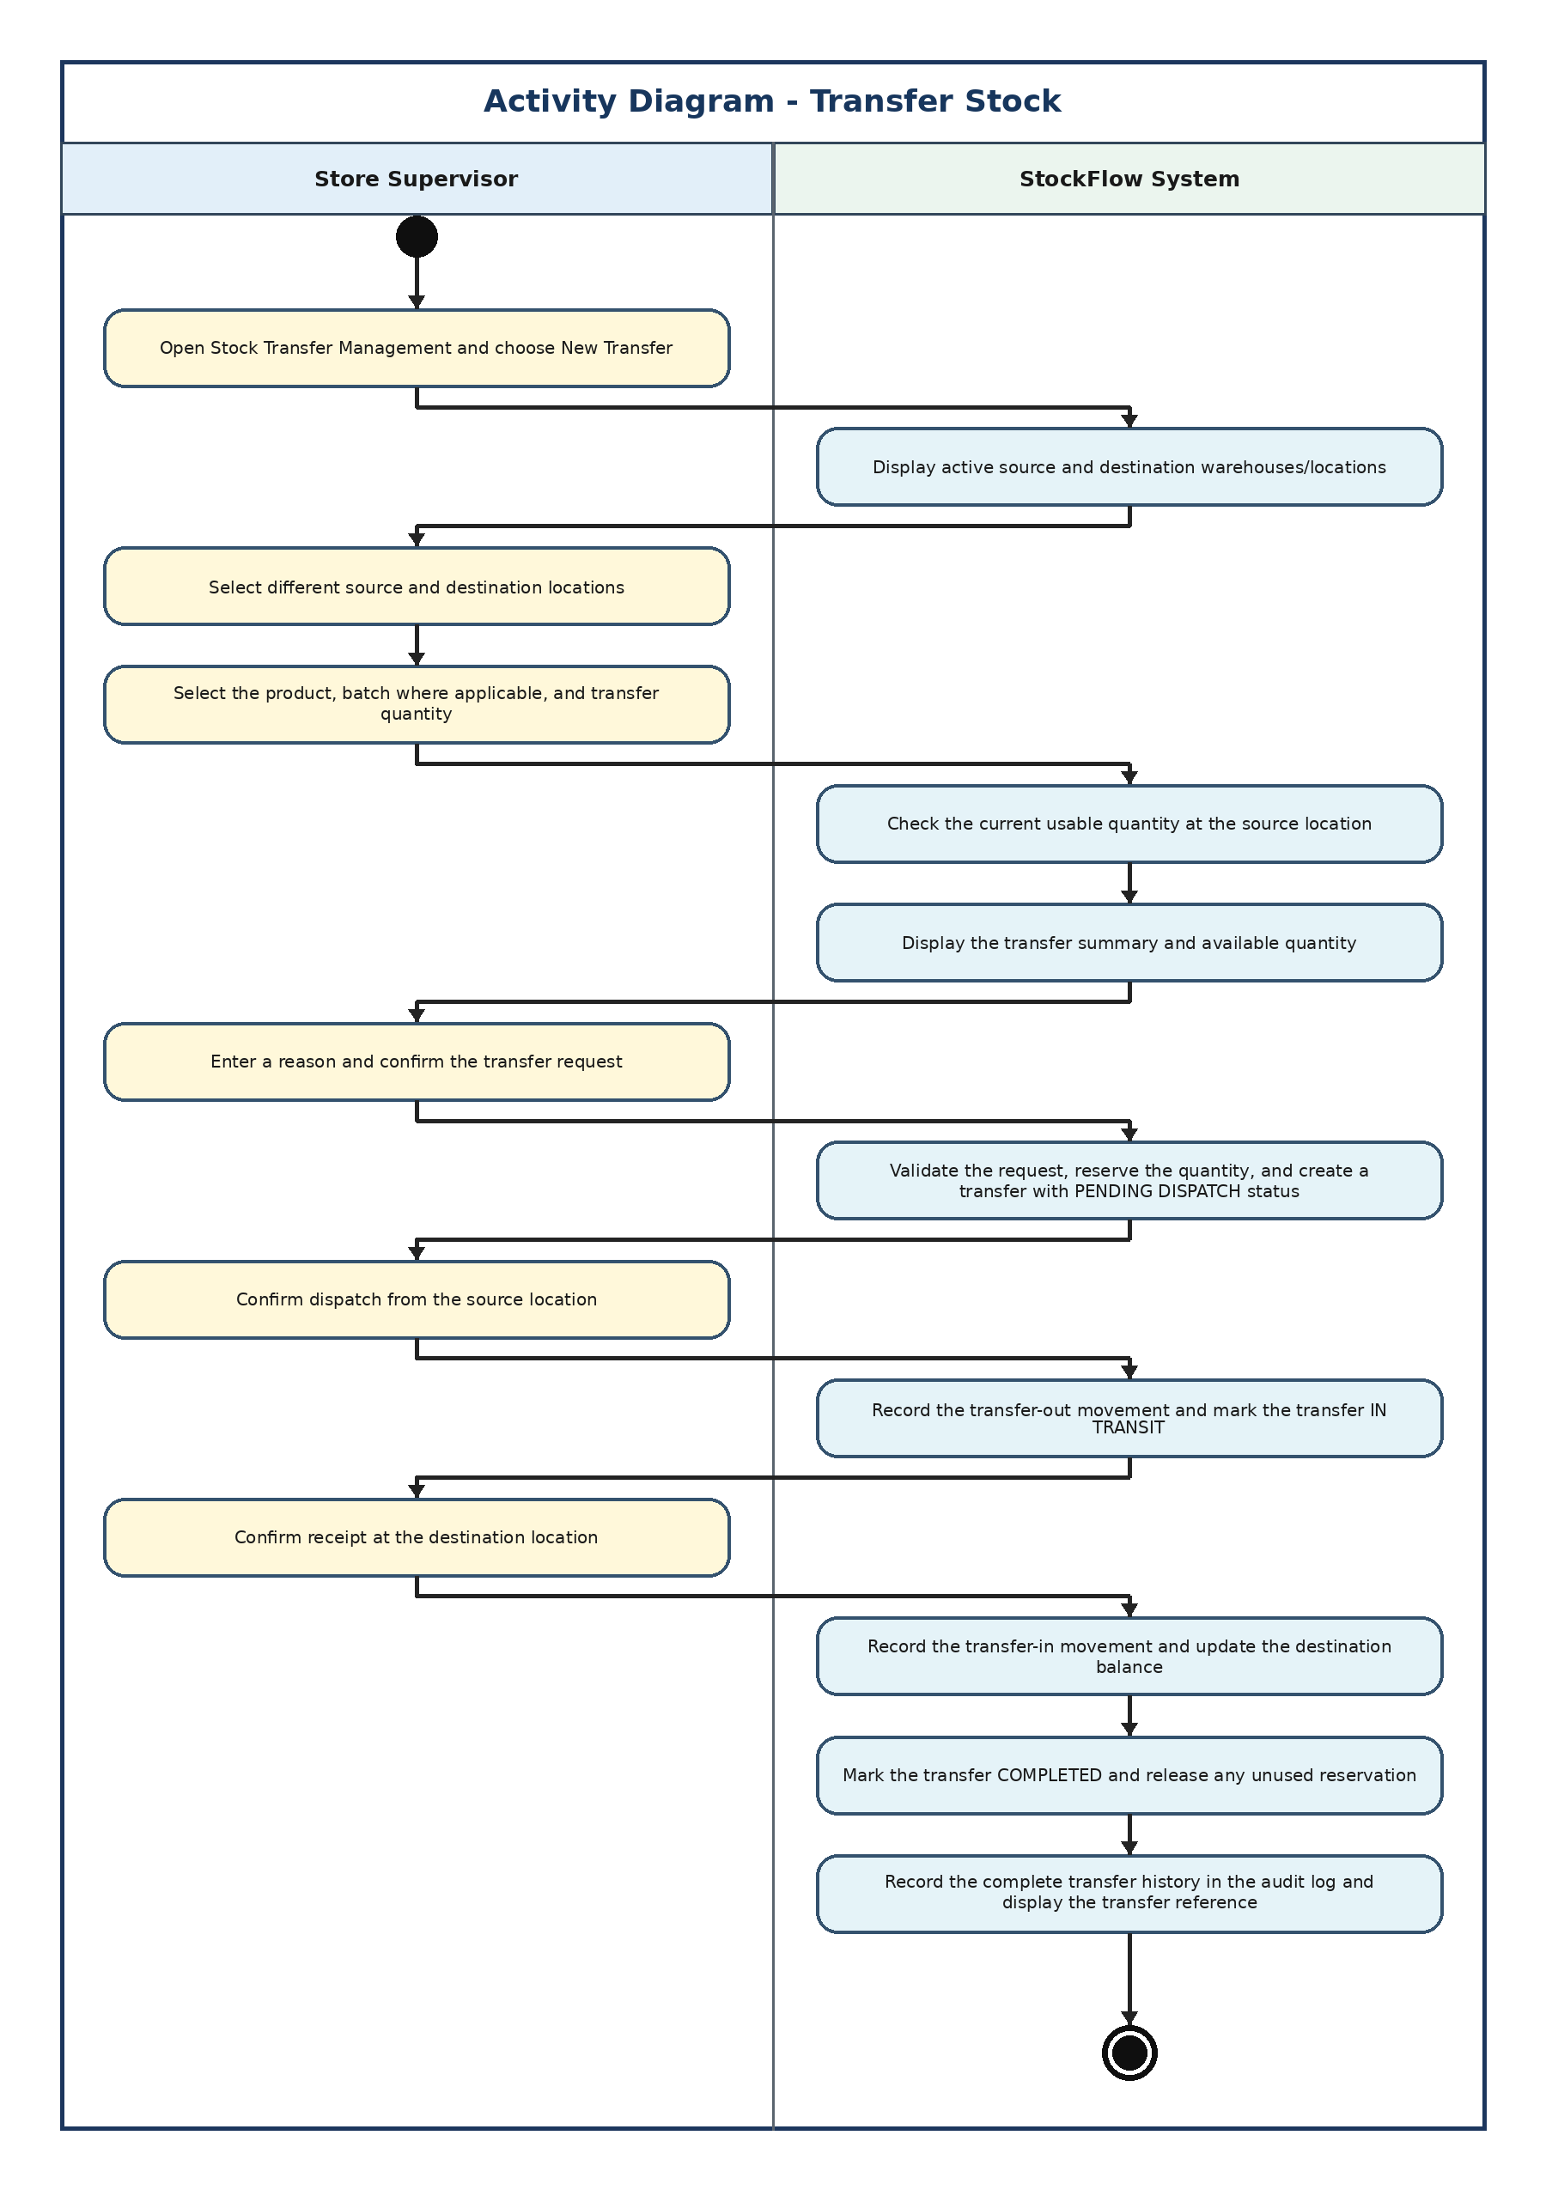

5. Issue Stock
Kavindi W.L.P.R. (IT25101519)
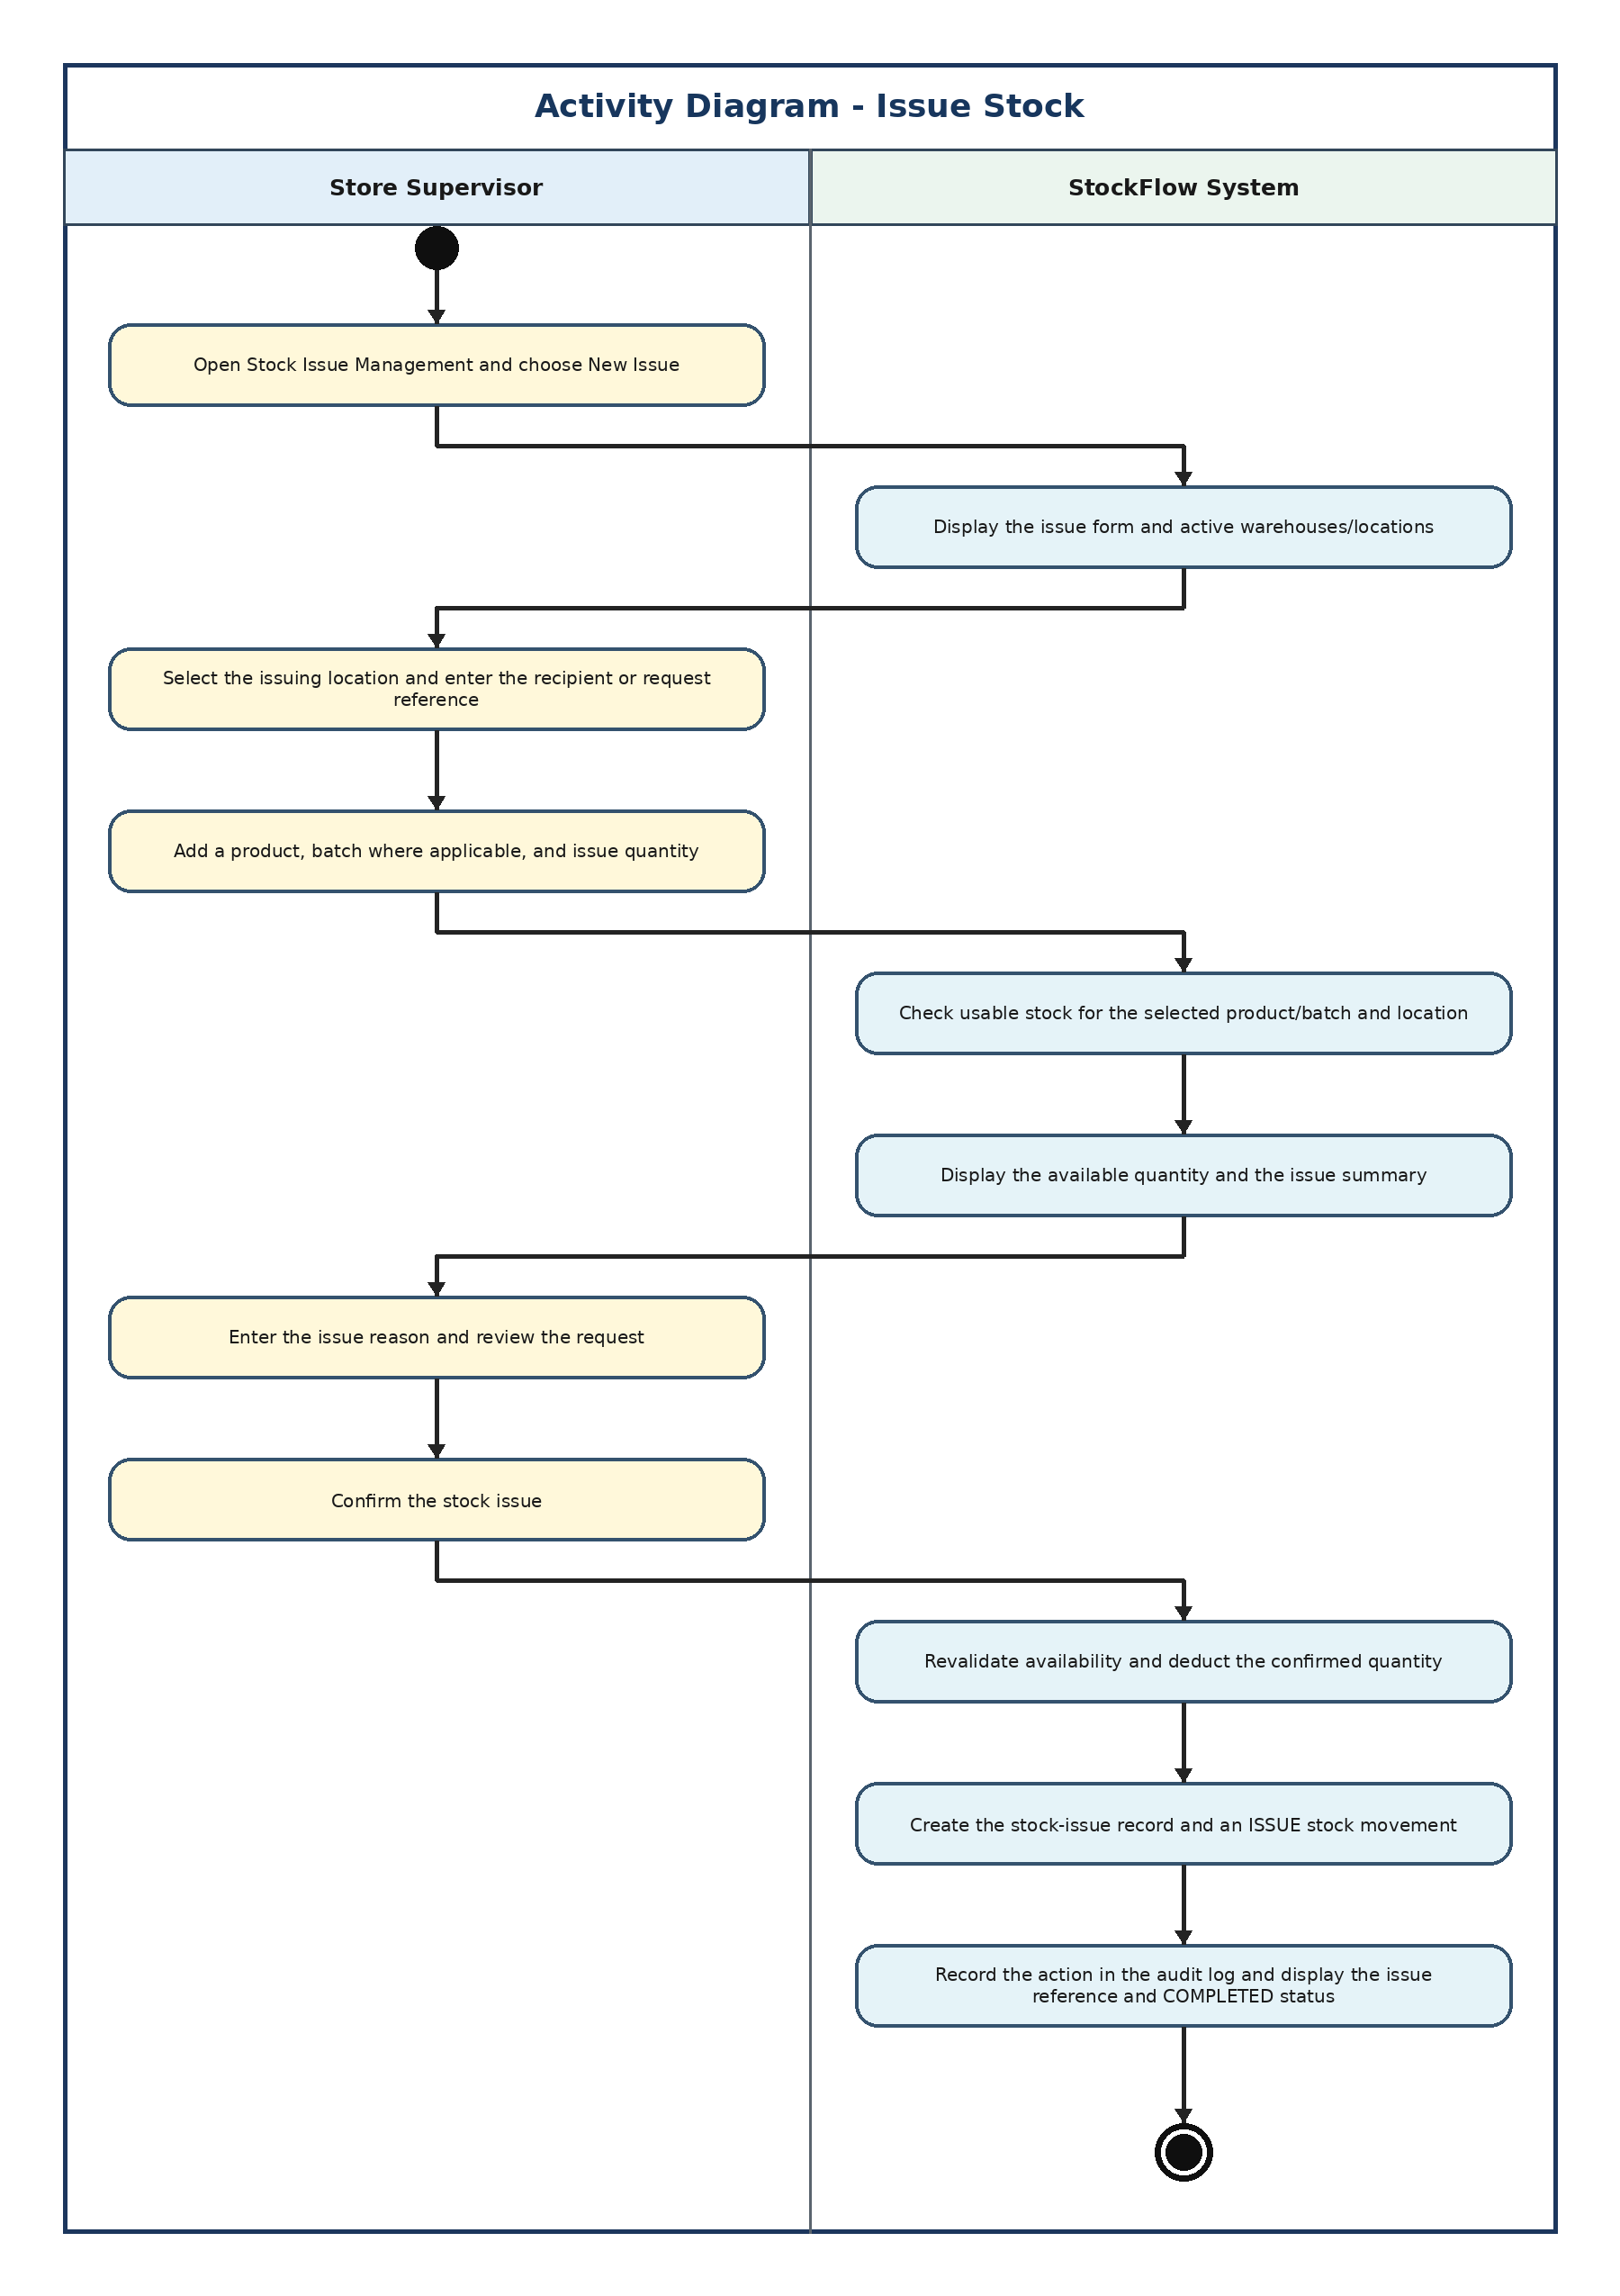

6. Process Stock Adjustment
Priyabhashitha G.J.S. (IT25101700)
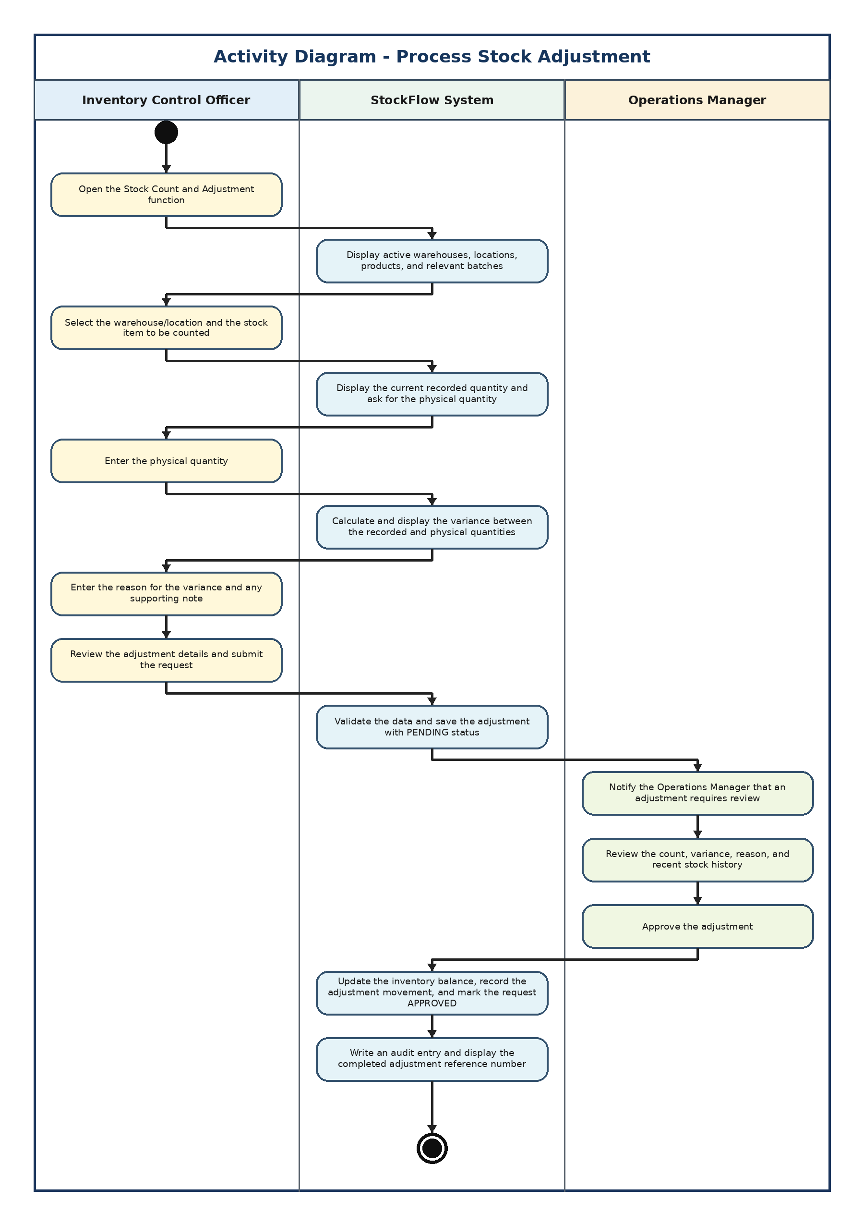

Ethical Considerations
StockFlow does not hold medical or payment data, but it does store staff accounts, supplier and customer contact details, and records that decide how much stock the company has. Wrong or misused data here can lead to shortages, over-ordering or someone being blamed for a loss they did not cause, so we treated the points below as part of the design and not as an extra.
Data Privacy
We only collect what is needed for inventory work, such as names, usernames, work emails and supplier or recipient contact details. Each role only reaches the pages it needs, and this is checked on the server, not only hidden in the menu. The Customer Service Coordinator, for example, can view stock and issue status but cannot change anything. Personal details are not shown in the general stock reports.
Security and Access Control
Passwords are never stored as plain text; they are saved as BCrypt hashes. The database and first-run passwords are read from environment variables instead of being written in the code. Only the IT and Systems Officer can create accounts, change roles or reset passwords, and accounts are deactivated instead of deleted so old records still point to a real user.
User Consent and Transparency
Staff are told when they receive an account that their approvals, adjustments and other important actions are recorded, why they are recorded and who can review them. Nothing is collected in the background beyond what users enter while doing their job, and the data is not shared outside the company.
Accountability and Data Integrity
Every stock change is saved as a stock movement with a reference number, and balances cannot go below zero. Sensitive changes like stock adjustments and purchase orders need Operations Manager approval first. Used records are deactivated rather than permanently deleted, and a version field stops two users from overwriting the same balance at the same time. The audit trail, which records who did what and when, will be finished in Sprint 4.
Accessibility
The staff workspace uses one consistent sidebar, clear labels, readable contrast and plain validation messages. It adapts to tablet and mobile widths and respects the reduced-motion setting. Read-only pages are clearly marked and important actions ask for confirmation, which helps new or less technical users avoid mistakes.
Data Retention
Keeping records forever increases privacy risk, but losing them hurts the business. The company should decide how long records are kept, protect and test backups, and remove data safely when it is no longer needed. Only made-up demo data is used for testing, and it is kept apart from the clean submission database.

